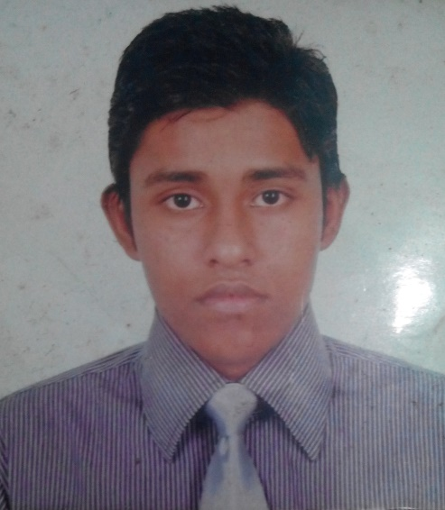**CURRICULUM VITAE**

**Abdullah Al Mamun**

Student, Computer Science &Engineering (CSE),

Stamford University Bangladesh

Email: jituus102076@gmail.com

Contact No: 880-1681803885

**Career Objective:**

Gain utmost competence in the field of Information Technology and IT Research through enthusiasm, hardwork, sincerity and brilliant.Moreover,serve for the welfare of the society, business.

**Personal Information:**

Name :Abdullah AL Mamun

Nick Name :Jitu

Father’s Name:Asadul Islam

Mother’s Name :Gulnahar Begum

NID : 19912696635000274

Date of Birth: 4th August 1991

Gender : Male

Marital Status : Unmarried

Religion : Islam

Nationality : Bangladesh

Address : 198/6 NoyatolaMoghbazar Dhaka-1217

Contact number : 01681803885

Email : jituus102076@gmail.com

**Educational Profile:**

|  |  |  |  |  |  |
| --- | --- | --- | --- | --- | --- |
| Exam Title | Concentration/Major | Institute | Board | CGPA | Year Of Passing |
| SSC | Science | NazrulShikshalaya | Dhaka | 3.69 | 2007 |
| HSC | Science | Tejgaon College | Dhaka | 3.10 | 2009 |
| Bachelor Of Science(running) | Computer Science & Engineering | Stamford University Bangladesh | Dhaka | 2.91 | 2016 |

**Skills:**

* MS Word
* MS PowerPoint
* HTML
* Adobe Photoshop

**Hobbies:**

* Travelling
* Reading Books
* Watching Movies

**Reference:**

ShahariarParvage

Stamford University Bangladesh

Address:[ 435/1/A Wireless RailgateMoghbazar

Tel: 01874261961

Email: [shahariar_cse@yahoo.in](mailto:shahariar_cse@yahoo.in)